Fast Frequency Response (FFR), Primary, Secondary and Tertiary Reserve (POR, SOR, TOR1 & TOR2)
System Services
Test Report
Battery ESPS
Unit Name

DISCLAIMER:
This Document contains information (and/or attachments) which may be privileged or confidential. All content is intended solely for the use of the individual or entity to whom it is addressed. If you are not the intended recipient please be aware that any disclosure, copying, distribution or use of the contents of this message is prohibited. If you suspect that you have received this Document in error please notify EirGrid or its subsidiaries immediately. EirGrid and its subsidiaries do not accept liability for any loss or damage arising from the use of this document or any reliance on the information it contains or the accuracy or up to date nature thereof. Use of this document and the information it contains is at the user’s sole risk. In addition, EirGrid and its subsidiaries strongly recommend that any party wishing to make a decision based on the content of this document should not rely solely upon data and information contained herein and should consult EirGrid or its subsidiaries in advance.
Further information can be found at: http://www.eirgridgroup.com/legal

Document Version History
Revision 3.0, published 30th July 2021
Version | Date | Comment | Name | Company
0.1 | Insert date | Minor version (v0.1) - First submission for review and approval | Insert name | Insert company
1.0 | Insert Date | Revised to version 1.0 following approval by EirGrid, SONI. | Insert Name | Unit Company Name

Introduction
The Unit shall submit the latest version of this test report template as published on the EirGrid or SONI websites.
The report shall be developed for technical and non-technical readers and shall follow the agreed test programme. The report is submitted to generator_testing@eirgrid.com or generator_testing@soni.ltd.uk as appropriate.
Submission of this document is required if a Unit does not have and existing FFR, POR, SOR, TOR1 or TOR2 contract or is making changes or updates to any of the effected parameters.
To complete the report, the Unit shall have either:
- Recorded frequency response data as per the test procedure agreed with EirGrid, SONI; or
- Performance Data showing frequency response capability.
Any issue with meeting any requirements or completing this report, please contact generator_testing@eirgrid.com or generator_testing@soni.ltd.uk as appropriate.

Abbreviations
AAP Available active power
ESPS Energy Storage Power Station
FFR Fast Frequency Response
HV High Voltage
Hz Hertz – unit of frequency
kV kilovolt
MW Mega Watt
MEC Maximum Export Capacity
MIC Maximum Import Capacity
POR Primary Operating Reserve
SOR Secondary Operating Reserve
TOR Tertiary Operating Reserve

Battery Data
The data in the table below should be provided for the ESPS specific to the test.
ESPS Name | ESPS to Specify  (name per connection agreement)
ESPS Test Coordinator and contact number: | ESPS to Specify
Associated 110 kV Station | ESPS to Specify
ESPS connection point | ESPS to Specify  (i.e. T121 in XXX Distribution or Transmission Station)
ESPS connection voltage | ESPS to Specify
ESPS Connection Type | ESPS to Specify  (TSO, DSO Topology 1, DSO Topology 2 etc.)
Installed module type, MW size and quantity | ESPS to Specify
Contracted MEC | ESPS to Specify
Contracted MIC | ESPS to Specify
Registered Capacity | ESPS to Specify
Energy Storage Capacity | ESPS to Specify
% Charge maintained in normal operation | ESPS to Specify
Limiter applied to Exported MW | ESPS to Specify
Limiter applied to AAP | ESPS to Specify
DMOL | ESPS to Specify
RoCoF Capability | ESPS to Specify

System Services definitions
The definitions referenced in this document are for indicative purposes only. In the event of inconsistency between the definitions in this document and those in the DS3 System Services Agreement, the definitions in the DS3 System Services Agreement shall prevail.

Fast frequency response (FFR)
FFR is defined as the additional increase in MW output from a unit or a reduction in demand following a frequency event that is available within two seconds of the start of the event and sustainable for at least eight seconds afterwards.
The extra energy provided by the MW increase, in the timeframe from the FFR response time to 10 seconds shall be greater than any loss of energy in the ten-to-twenty second timeframe afterwards due to a reduction in MW output. The energy provided and drawn should be compared to the pre-event output.

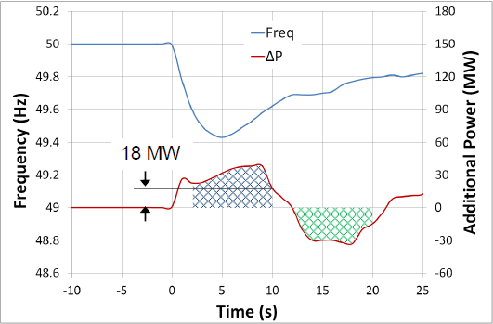
Figure 1: Example graph showing the additional power provided to, and drawn from, the grid
As shown in the diagram above, in order to be eligible for FFR the amount indicated by the blue hatched area (Power provided) must be greater than the green hatched area (Power drawn).
Please note there are performance monitoring standards that apply for DS3 System Services and specific requirements for FFR. Further detail is available in the DS3 Performance Measurement Device Standards for Fast Acting Services document.

Operating Reserve (POR, SOR & TOR1)

Operating Reserve
Operating Reserve is defined as the additional MW output provided from Generation plant, reduction of Active power transfer to an external system or increase of Active power transfer to the Transmission system by interconnectors, or reduction in Customer demand, which must be realisable in real time operation to contain and correct any potential Transmission system deviation to an acceptable level.

Primary Operating Reserve (POR)
Primary Operating Reserve (POR) is the additional MW output (and/or reduction in Demand) required at the frequency nadir (minimum), compared to the pre-incident output (or Demand) where the nadir occurs between 5 and 15 seconds after an Event.

Secondary Operating Reserve (SOR)
Secondary Operating Reserve (SOR) is the additional MW output (and/or reduction in Demand) required at the frequency nadir (minimum), compared to the pre-incident output (or Demand) which is fully available and sustainable over the period from 15 to 90 seconds following an event.

Tertiary Operating Reserve band 1 (TOR1)
Tertiary Operating Reserve band 1 (TOR1) is the additional MW output (and/or reduction in Demand) required at the frequency nadir (minimum), compared to the pre-incident output (or Demand) which is fully available and sustainable over the period from 90 seconds to 5 minutes following an event.

Tertiary Operating Reserve band 2 (TOR2)
Tertiary Operating Reserve band 2 (TOR2) is the additional MW output (and/or reduction in Demand) required compared to the pre-incident output (or Demand) which is fully available and sustainable over the period from 5 minutes to 20 minutes following an Event.

Assessment
The MW amount is based on the absolute lowest sustainable value the unit is capable of in the given timeframe for the service.

POR, SOR, TOR1 Assessment Examples
The following are a few examples of how the different operating reserve services could be graphed and how they can be assessed:
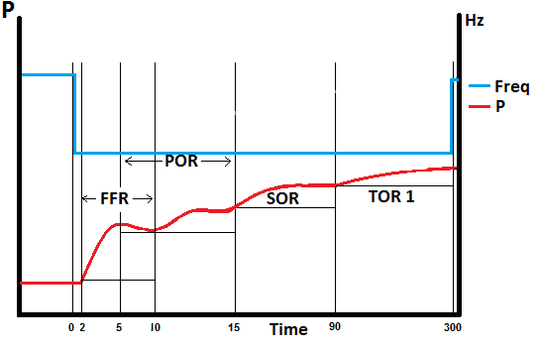
Figure 2: Example of how to measure the lowest MW value for each service
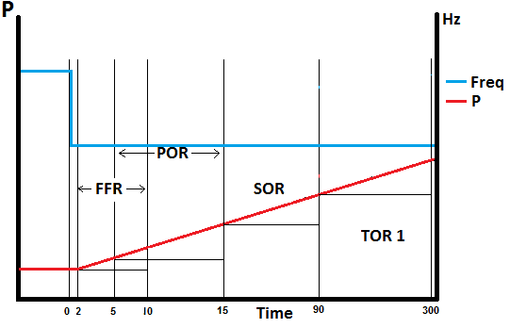
Figure 3: Levels shown with a linear response
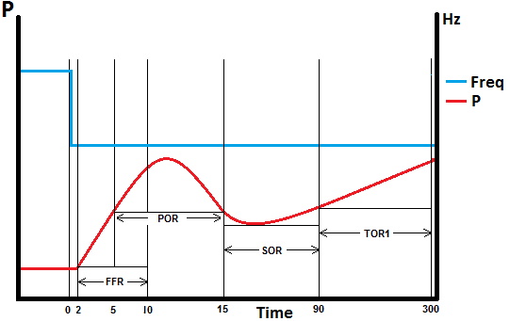
Figure 4: Levels shown with an overshoot response
The lines show where the lowest sustainable values are measured over the timeframe for each service.

FFR Assessment
The assessment of FFR is the lowest MW amount sustained over the 2 –10 second timeframe, compared to the pre-event output.
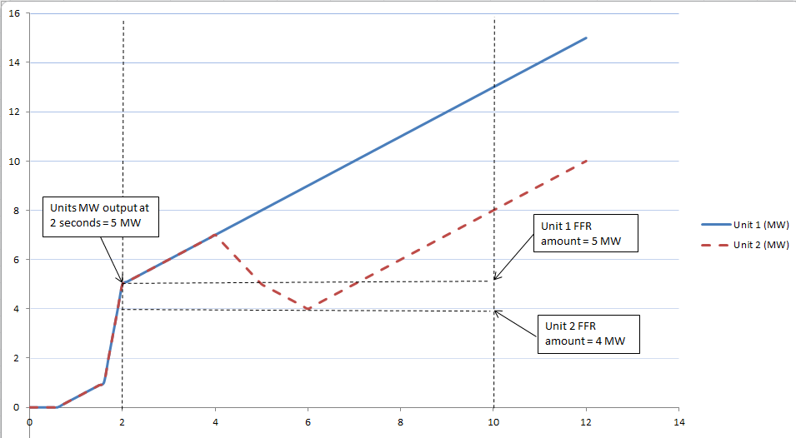
Figure 5: Example graph showing two units frequency response in the FFR timeframe
In figure 5, above, Unit 1 reaches 5 MW by the two second mark and continues ramping upwards over the course of the FFR timeframe. 5 MW is therefore the lowest sustainable MW amount provided over the timeframe by Unit 1.
Unit 2 also gets to 5 MW by two seconds, like Unit 1. Unlike Unit 1, it drops to 4 MW in the time frame. 4 MW is therefore the lowest sustainable MW amount provided over the timeframe by Unit 2.
The Pre-Event output is defined as the mean of the providing unit’s output between T-1.5 seconds and T-0.5 seconds from the time of the frequency passing through the reserve trigger for the providing unit (T=0). In the example above the pre-event output is 0MW.

FFR Response Time
A Providing Unit’s contracted FFR Response Time is the time from when the frequency falls through its contracted Reserve Trigger (T=0) to the time at which the Providing Unit must have achieved its contracted FFR volume, as dictated by its contracted FFR response curve.
The FFR response time provided in Section 7.4 shall be based on test data.
Please note that the FFR Response Time, as recorded on the Providing Unit’s installed performance measurement equipment, will be evaluated as part of the FFR performance monitoring process.
The product scalar for faster response of FFR will be based on the FFR response time of the Providing Unit.
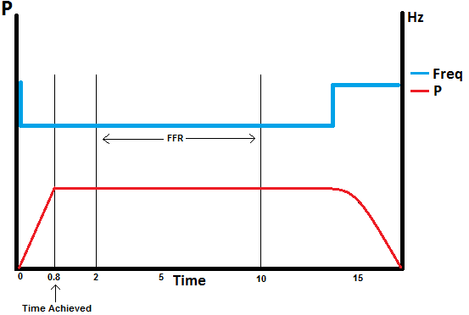
Figure 6: FFR volume achieved before the FFR time period

FFR Eligibility
Measure the energy provided (in MW seconds) in the timeframe from FFR response time to 10 seconds following an event, compared to the pre-event output. Measure the energy drawn (in MW seconds) during the 10-20 second timeframe following an event, compared to the pre-event output.
If a unit draws more energy from the grid in the 10 – 20 second period after this then it will not qualify for an FFR contract.
Figure 5 FFR Energy provided in blue and FFR Energy withdrawn in green

Results

Summary
Testing was completed on [DATE].
[Insert comment on the results, highlighting any issues encountered in performing the test or in analysing the results.]
[Insert Report summary]
[Include any relevant test notes here, relating to how the test was carried out or to any specific conditions encountered during the test.]
[Any abnormal behaviour during the test (spikes, dips, unusual effects, etc.) shall be noted and documented. The reasons behind these shall be detailed along with any corrective actions taken and what its effects are on the unit and/or the result. If possible a clear graph of the issue shall also be presented.]

Trigger Frequency Test Results
ESPS to include a table showing the battery unit’s responses to the steps of the Trigger Frequency tests:
TRIGGER FREQUENCY TEST
No. | Condition | Result
X | Include: MW set-point, frequency injection | Include MW Import / Export

Dynamic Frequency Response Test Results
ESPS to include a table showing the battery unit’s responses to the steps of the Dynamic Frequency Response tests:
DYNAMIC FREQUENCY RESPONSE TESTS
No. | Condition | (a) FFR Energy Provided  (2 – 10 Sec) | (b) FFR Energy drawn  (10 – 20 Sec) | FFR Eligibility: is (a) MW > (b) MW? | FFR | POR  (5 -15 Sec) | SOR  (15 – 90 Sec) | TOR1  (90 – 300 Sec) | TOR2  (5-20 Min)
X | Include: MW set-point, frequency injection, wait duration | ______MW | ______MW | ______MW | ____MW | ____MW | ___MW | ___MW | ___MW

Display of Results

Grahical Analysis
[Insert full plots of the results demonstrating the frequency response of the unit. Graphs should be clear and highlight all relevant values and time periods, including levels. All Graphs should be clearly labelled and easy to read.]
Graphs should clearly show the MW value prior to frequency event, and the minimum sustained MW value for each time period. Available Active Power should be included in all graphs
[Graph should be a time series plot with Power and Frequency on the y axis and time on the x axis.]

FFR Response Time
[Graph should be included to show detailed profile of FFR Response. Graphs may include 0-20 seconds / 0-10 seconds / 0-2 seconds / 2-10 seconds and should provide clear indication as to when the proposed level of FFR output is achieved.]

Additional Information
[Include any relevant test notes here, relating to how the test was carried out or any specific conditions encountered during this test]

FFR Response Characteristics
No | Details | Value | Comment
1 | FFR Response Time | _____ms | ESPS to fill in where applicable
2 | Is the response Static or Dynamic? |  | ESPS to fill in where applicable
 | Dynamic Response Characteristics
3 | Reserve Trigger | ____Hz | ESPS to fill in where applicable
4 | Trajectory Capability | ____Hz | ESPS to fill in where applicable
 | Static Response Characteristics
5 | Reserve trigger | ____Hz | ESPS to fill in where applicable
7 | Number of discrete steps |  | ESPS to fill in where applicable
8 | Max discrete step value for static provision | ____MW | ESPS to fill in where applicable

Proposed Volumes
Please provide the proposed contract values for each service as per test results.

1 | Proposed Maximum FFR Available Volume | ____MW
2 | Proposed Maximum POR Available Volume | ____MW
3 | Proposed Maximum SOR Available Volume | ____MW
4 | Proposed Maximum TOR1 Available Volume | ____MW
5 | Proposed Maximum TOR2 Available Volume | ____MW

Reserve Curve Characteristics
The ESPS shall provide a proposed reserve curve for each service based on test data showing the levels of Operating Reserve at varying MW outputs.

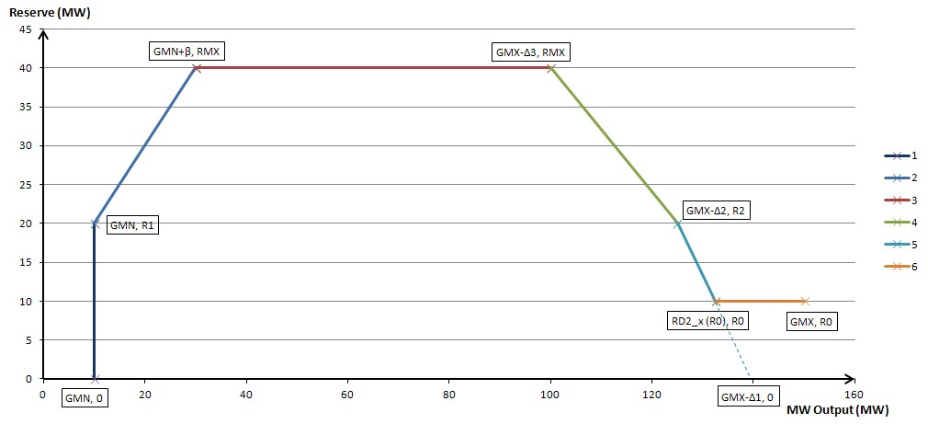

 | FFR | POR | SOR | TOR1 | TOR2
RMX (Max reserve volume)
GMN (Min Load / Min Gen)
R0
R1
R2
DELTA1
DELTA2
DELTA3
BETA

http://www.eirgridgroup.com/ or http://www.soni.ltd.uk/

